(Pt24)Title of Paper for ICACT Journal

(Pt11)First Author*, Second Author**, Third Author*
*(Pt10)First-Third Department, First-Third University, Address Including Country Name
**Second Company, Address Including Country Name
(Pt9)first.author@first-third.edu, second.author@second.com, third.author@first-third.edu
(Pt9)Abstract—These instructions give you guidelines for preparing papers for IEEE TRANSACTIONS and JOURNALS. Use this document as a template if you are using Microsoft Word 6.0 or later. Otherwise, use this document as an instruction set. The electronic file of your paper will be formatted further at IEEE. Define all symbols used in the abstract. Do not cite references in the abstract. Do not delete the blank line immediately above the abstract; it sets the footnote at the bottom of this column.

(Pt9)Keyword—About four key words or phrases in alphabetical order, separated by commas. For a list of suggested keywords, send a blank e-mail to keywords@ieee.org or visit http://www.ieee.org/organizations/pubs/ani_prod/keywrd98.txt

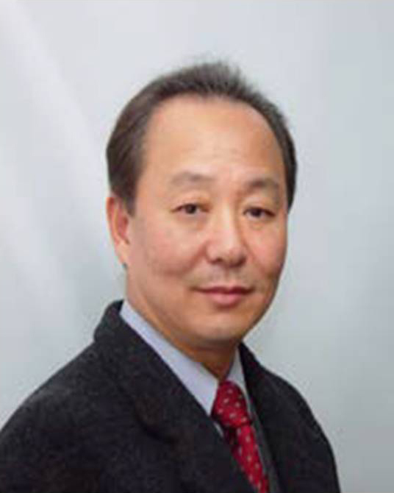
(Pt8)First A. Author (M’76–SM’81–F’87) and the other authors may include biographies at the end of regular papers. Biographies are often not included in conference-related papers. This author became a Member (M) of IEEE in 1976, a Senior Member (SM) in 1981, and a Fellow (F) in 1987. The first paragraph may contain a place and/or date of birth (list place, then date). Next, the author’s educational background is listed. The degrees should be listed with type of degree in what field, which institution, city, state, and country, and year degree was earned. The author’s major field of study should be lower-cased.
(Pt8)The second paragraph uses the pronoun of the person (he or she) and not the author’s last name. It lists military and work experience, including summer and fellowship jobs. Job titles are capitalized. The current job must have a location; previous positions may be listed without one. Information concerning previous publications may be included. Try not to list more than three books or published articles. The format for listing publishers of a book within the biography is: title of book (city, state: publisher name, year) similar to a reference. Current and previous research interests end the paragraph.
(Pt8)The third paragraph begins with the author’s title and last name (e.g., Dr. Smith, Prof. Jones, Mr. Kajor, Ms. Hunter). List any memberships in professional societies other than the IEEE. Finally, list any awards and work for IEEE committees and publications. If a photograph is provided, the biography will be indented around it. The photograph is placed at the top left of the biography. Personal hobbies will be deleted from the biography.

All the co-authors’ biographies should be written here also!

